Example of Article

Chapter I: Margins

Each element generates a rectangular area in the document called a box ("Box model").

The box consists of:

1. "Content" (e.g., text, image, etc.)

2. "Padding" - The surrounding internal margins

3. "Border"

4. "Margin"

The last three components are optional, meaning they can be zero.

The outer circumference of each of the four areas is called "Edge".

According to CSS, element sizes ("width" and "height" properties) refer to the content

itself ("Content") and do not affect the other areas of the box ("Box model")

that are created outside the content, but inside the box.

In contrast, the background of the element is defined for all of the above areas,

with the exception of external margins, which are always "transparent".

Saving these short rules will allow you to avoid unexpected problems

with displaying page elements in the future.

In Fig. 1 you will find a graphical interpretation of the box structure of elements in CSS.

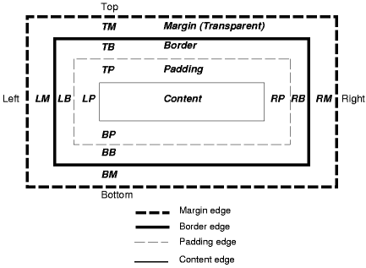

Fig. 1. Structure of frames and margins of an HTML tag by CSS

Chapter II: Equations

The time form of the periodically variable sinusoidal signal is expressed according to the relationship:

x(t)=Am1sin(2Pift+Fi0)

where:

• t - time,

• Am1 - amplitude of signal,

• f - frequency of signal,

• Fi0 - start phase of signal.

The authors of the article:

Jan Kowalski

email address: jan.kowalski@fake-mail.pl

Maria Nowak

email address: maria.nowak@fake-mail.pl

Source of the page: www.wikipedia.pl